A000-AFR-EGY-Ushabti-Deir-el-Bahri -Light Blue Faience-Dyn. 21-3rd Int. Period-1069--945 BCE

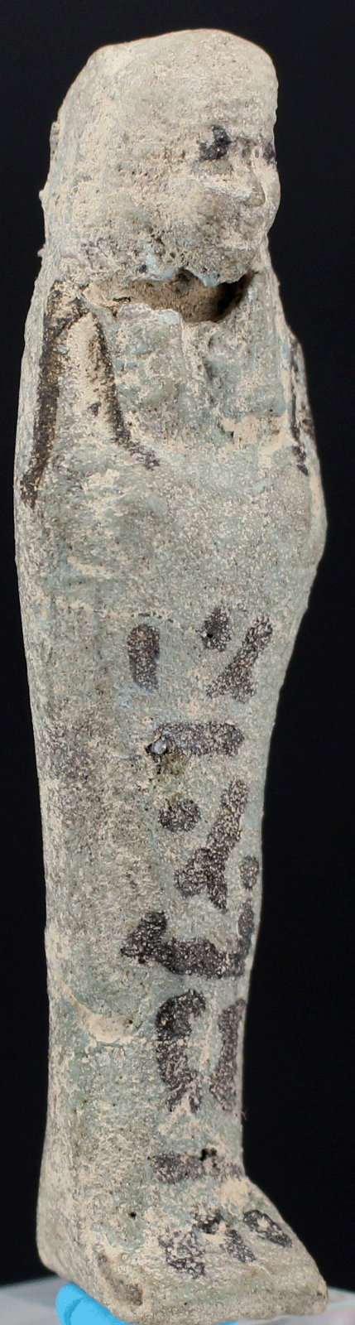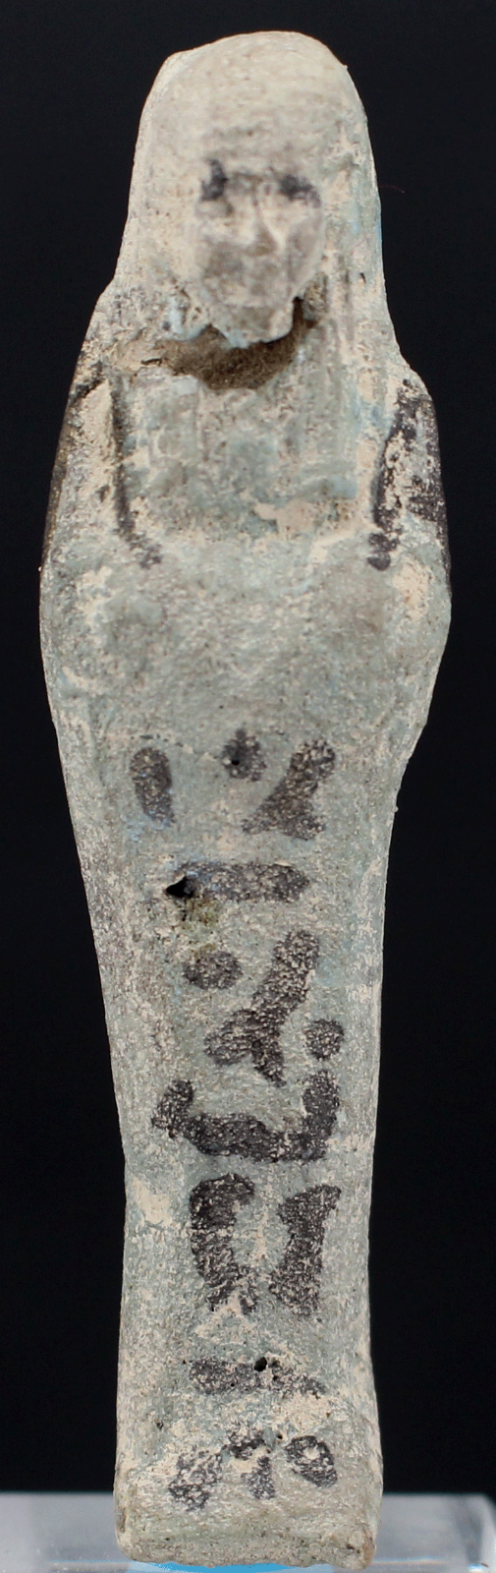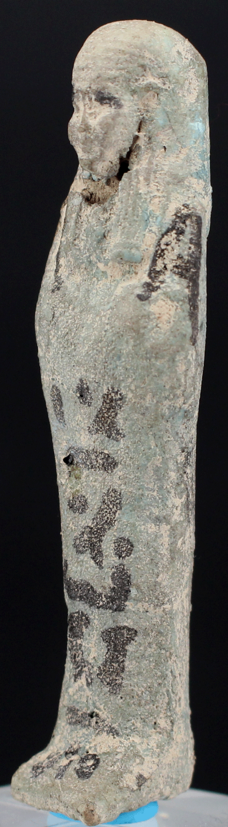

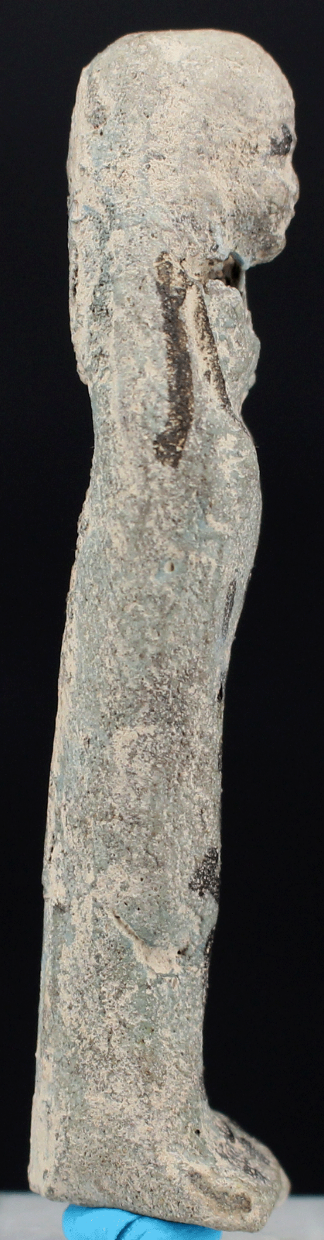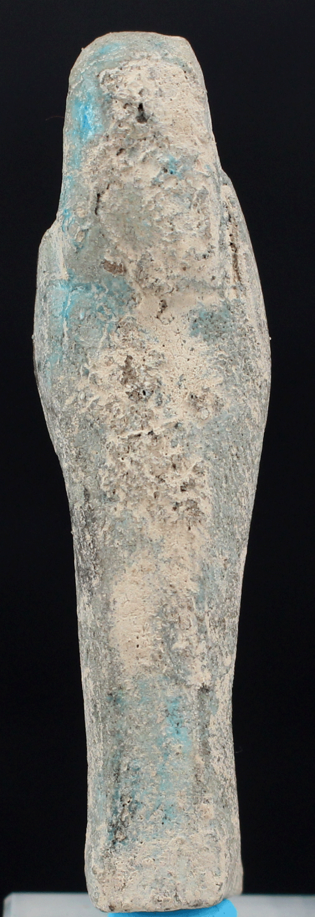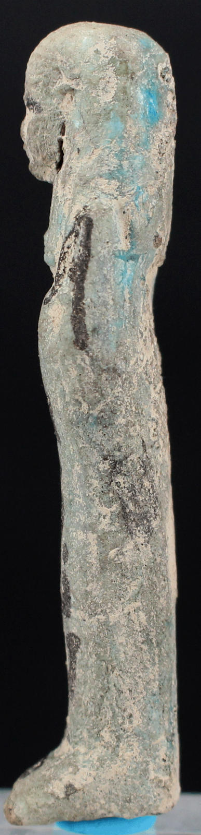

**Case no.:**

**Accession Number:**

**Formal Label:** A000-AFR-EGY-Ushabti-Deir-el-Bahri -Light Blue Faience-Dyn. 21-3rd Int. Period-1069--945 BCE

**Display Description:**

This Ushabti represents in its inferior hieroglyphics and abbreviated design features the political and economic decline during the Second Intermediate Period that witnessed the invasion of the Hyksos, Semitic raiders from their last onslaught on Sumeria in the east.

Ramesses III was the last monarch of the 20th Dyn. and the New Kingdom (1570 or 1544 BCE-11th c BCE; 18th -20th Dyn.), who began his reign with control that slowly diminished from 1186 to 1155 BCE due to the Hyksos invasions of the Nile delta and plaguing internal infrastructure problems as tributaries of the Nile silted up. The Semitic Hyksos (“rulers of foreign lands”) established themselves at Avaris in the Nile delta and initiated the 2nd Intermediate Period (c 1782 - c 1570 BCE).

After Ramesses III, Pharaohs of Dyn. 21 ruled from Tanis, which controlled Lower Egypt with difficulty and which was built with many of the cut-stones from Pi-Ramesses, which had been Ramesses’ capitol of Lower Egypt: the Nile tributary that the city had depended on had already silted up, a fate that was also to befall Tanis and its imported ashlar masonry as well.

To exacerbate matters even further, Middle and Upper Egypt was effectively administered by the High Priests of Amun at Thebes, who controlled 65 percent of the temple lands and 90 percent of Egyptian shipping (Clayton 1994: 175) further straining the pharaoh’s political and economic rule from Tanis. Towards the end point of this decline, the 3rd Intermediate Period ensued (Kitchen 1986).

This Ushabti, therefore, reflects the infrastructure’s economic stresses specifically on the ceramics of the religious establishment in Egypt during the 2nd Intermediate Period, as tribute to temples and funds for private votary objects was curtailed and as everyday economics and religious piety plunged to new depths (Marée 2010).

**LC Classification:**  DT86.S436

**Date or Time Horizon:** Dyn. 21, 2nd Intermediate Period (c 1782 - c 1570 BCE)

**Geographical Area:** Thebes, Deir-El-Bahri, the mountainside remains of temples including Queen Hatshepsut's tiered temple, chapels and tombs.

**Map:**

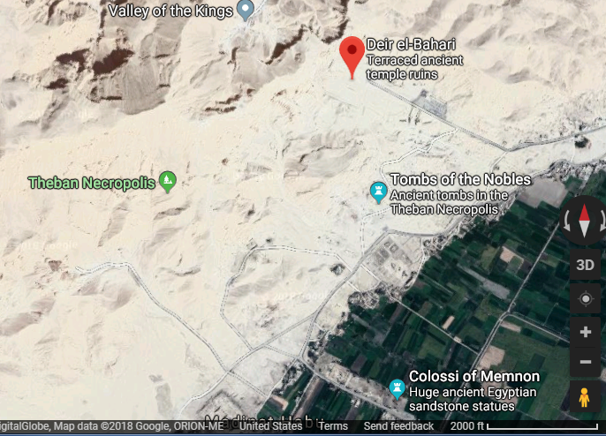

**GPS coordinates:** [25°44′18″N 32°36′28″E](https://tools.wmflabs.org/geohack/geohack.php?pagename=Deir_el-Bahari&params=25_44_18_N_32_36_28_E_region:EG_type:landmark)

**Cultural Affiliation:** 21st Dyn, 2nd Intermediate period

**Medium:** Light blue faience

**Dimensions:**

**Weight:**

**Condition:**

**Provenance:**

**Discussion:**

**References:**

Černý, Jaroslav. 1946. “Studies in the Chronology of the Twenty-First Dynasty,” *Journal of Egyptian Archaeology* 32: 24-30.

*­­­*Clayton, Peter. 1994. Chronicle of the Pharaohs. London: Thames and Hudson.

Kitchen, Kenneth A. 1986. *The Third Intermediate Period in Egypt (1100–650 BC)*. 3rd

Ed. Warminster: Aris and Phillips.

Seiler, Anne. “The Second Intermediate Period in Thebes: Regionalism in pottery development and its cultural implications.” In Marcel Marée, *The Second intermediate period (thirteenth-seventeenth dynasties) : current research, future prospects.* Orientalia Lovaniensia analecta, 192. Leuven; Walpole, MA: Peeters, 2010, pp. 19-54.